Sports Vision at the University of Twente
Before you lies the vision of "Sports at the University of Twente" of the Student Union, CFM sport and the Sportkoepel. This document contains the joint vision of these three parties, the sports sector, on sports at the University of Twente. This vision replaces the previous document from 2014.

List of definitions
The definitions below are based on the circumstances as we know them at the University of Twente (UT) and can therefore differ from definitions as described by other organizations.
Active sports: weekly participation in at least one competition or training moment.
Agonal movement skill games: sports types in which elements of game form, competition and movement can be recognized.
Agonal skill games: sport types where elements of game form and competition can be recognized.
Adventure sport: a sport whereby adventure and excitement are experienced.
Movement culture: individual and collective taught and acquired body language, expressed in sports and games, among other things.
Mixed sports: the collective name for recreational sport, competitive sport, fitness sport, fun sport and adventure sport.
Campus: the geographic terrain that the UT covers, as well as the Watersports complex, the Witbreuksweg and everything that can be counted within the border of the Campus.
CFM-Sport: the Sports department of the University of Twente, responsible for, among other things, facilitating sports for students and staff and rentals to external parties.
External users: all users who do not fall into the category of students or employees. These users can be both individuals and organizations that make use of the sports offer and facilities.
Fitness: sports as a means to pursue physical fitness, often in favour of health.
Bonding sport: a sport that is practiced as a club.
Group: a group is formed if people practice a team sport or sports are practiced in a club.
Qualification: learning to move properly, making yourself available on the basis of capacities.
Employees: employees of the UT.
Personal education: learning to prioritize yourself and give meaning to the UT exercise and sports offer.
Pleasure sport: sport whereby pleasure is exclusively achieved.
Performance sport: sport in which performance must be delivered, the basic form is therefore the control of fundamental movement skills. These include several training sessions per week.
Recreational sport: a sport meant for recreation, relaxation, and/or social contact. This involves one training moment per week.
Sports sector: consists of the Student Union, Sportkoepel, and CFM-Sport.
Socialisation: students and staff are introduced to the movement culture of the UT in the sense of, for example, learning to deal with diversity and learning to collaborate, as well as adapting to the standards of the UT community.
Playful movement skill games: sport types where elements of game form and movement can be recognized.
Sport: physical activity for relaxation with game and competitive elements or a specific goal, where condition and skill are required or promoted, and for which certain rules apply.
Sportkoepel (SK): general Drienerlose Student Sport Foundation “Sportkoepel Universiteit Twente”, with the general board guiding all student sports associations at the University of Twente. The Sportkoepel is an umbrella foundation of the Student Union.
Student Union (SU): Student Union University of Twente foundation, the umbrella organization for student activism at the University of Twente, responsible for, among other things, policy responsibility in the field of sport for students.
Students: students at the University of Twente and those of institutions with which the SU has entered into a partnership in the field of Sport & Culture (for example ArtEZ).
UT community: consists of all students and staff connected to the University of Twente as well as residents of the Campus.
Free sport: sport that is not practiced in an association (for example fitness, group lessons and courses, but also walk-in hours with free room space).
Competition sport: sport providing the experience of tension of a competition, for performance and for competitive relaxation. The athlete participates in a form of competition recognized by a federation.

Context
The Student Union, CFM-Sport and the Sportkoepel have chosen to formulate a joint vision of sports at the UT. There are several reasons for this.

Change in demand from sports associations
The current sports vision was written in 2014, a time in which sports at the UT were practiced in many cases to connect and for socializing. In 2019 this is still the central principle, but sport is now increasingly being used to become physically and mentally fit. In addition, many associations now want to focus more on sports in a manner of performance.

Growth of free sports
The demand for free sports has grown in recent years. A strong increase in the use of fitness facilities, group lessons and courses are visible. To compensate for this, the sports sector offers a wide range of free sports. In this way, the sports sector flexibly grows with the demand for free sports. A long-term vision is, however, desirable to remain successful in the future.

Diversity of the UT community
The UT distinguishes itself from other universities with its student and employee population. The campus and therefore also the sports sector must develop into an inspiring meeting place for a very diverse and rapidly changing UT community. A growing number of participants with a high degree of diversity and wishes will participate in activities within the sports sector.

Sports facility capacity reaching its maximum
The growth of both club sport and free sport ensures that the maximum capacity of a wide number of basic sports facilities has been achieved. Sports are currently being conducted at very unfavourable and late times, which in the case of students, for example, results in less attention payed in the lecture hall the following morning.
In addition, there is a great demand for a very diverse range of sports due to a growing diversity within the UT community.

Student participation is changing due to changes in education
Student participation is expressed in sport in two ways. Firstly, in the form of bounded and non-bounded sports participation. In addition, students participate in the boards and committees of student sports associations. It is desirable to increase the total student participation in the sports sector. Due to increasing pressure from the government to study faster, it is more difficult to fill committees and boards. This is a threat to the entrepreneurship of the sport sector and solutions must be found for this.
Students are experiencing more study pressure. Employees are experiencing more work pressure. Both groups will therefore consciously choose which activities they undertake to develop and relax themselves. It is important to consciously deal with these developments through this vision. A rapidly changing work and education climate requires flexibility from the sports sector in order to continue to inspire students and employees to participate in sports and student activism.

Importance fort the UT
The core values of the UT are: society-oriented, synergy-driven, entrepreneurial and international. The sports sector is inextricably linked to this. In a broad sense, sport contributes to the social awareness of students and staff. Sport brings people together and ensures interaction, it contributes to the social and emotional development of students and employees and ensures relaxation. As a result, sport makes a major contribution to the self-development and well-being of students and staff.

Sports and culture as a joint UT service
A frequently seen international trend is that sport and culture are increasingly coming together. Playful movement skills games and agonal skills games can often be labelled as either culture or sport. The UT is responding to this by bringing sports and culture together under one service. The Student Union strongly supports this trend and sees equal policy principles as favourable for personal development and socialization. These agreements must be apparent from the sports and culture vision.

Vision 2030
In 2019, the UT established its central UT vision, "vision 2030". Movement and sports play an important role in this vision. After all, sports on campus is the place for interaction, development and relaxation of students and staff.

The national view on sports
The view of sport from the perspective of the government is subject to change. It is a sector that has been widely discussed in recent years. The government often focuses on an athletic Netherlands, as described in the Sport Toekomstverkenning (STV). The STV is intended to sharpen thoughts about the future of sport. It seems as if sport is playing an increasingly important role in society and is being seen more as a basis for well-being and success. Partly as a result of this, it is also crucial that UT students and staff come into contact with sports as broadly as possible.

Introduction
The sports and exercise program at the UT consists of a varied range of sports and exercise activities. Students and employees are given the opportunity to make their own choices about which activities they participate in to develop themselves personally in exercise and sports. The Sports Vision at the University of Twente 2014 focused on the choices of the sports on offer in coordination with the UT community. A new perspective is the choice by students and staff to partake in different sports and their accompanying motives to move. This approach leads to a demand-oriented approach of the sports sector. This idea is the foundation of the Sports Vision at the University of Twente 2019.
Students and employees have different motives for participating in sports. Some attach importance to social contact and others consider competition or excitement important. Within a sporting activity, a context is created in which motivation is found, with fun being the most important motivator. In addition, the sports sector is aware that pleasure is the greatest motive for achieving student activism.

Mission
The sports sector encourages and facilitates students and staff to develop personally, interact and relax through exercise and sport.

Vision
The UT community lives, works and studies on and around the Campus. Playing sports at the University of Twente offers the UT community the opportunity for healthy relaxation in the midst of an active life. Participating in the sports community is easy and accessible. The uniform rules and universal values within sports (sportsmanship and teamwork) encourage integration within the entire and diverse UT community; both international and national, students and employees meet during sports. As large part of the UT community uses sport and exercise as a means of personal development, relaxation and integration.
Students are the primary users of the sports facilities and together with employees form the heart of the sports sector. These different user groups exercise as much as possible with each other. Students and employees exercise to connect (united by friendship), sports to feel fit (a vital campus), sports to win (to the top) and sports to experience (find harmony).
Students explicitly shape sports activities and sports clubs themselves. This student-driven mentality ensures an entrepreneurial, dynamic and flexible sports sector. This is supported by the Student Union, CFM-Sport and the Sportkoepel. These organizations provide a fixed structure, advising and supporting sports clubs and other enterprising users. These organizations also anticipate a dynamic, flexible and student-driven sports sector by, where possible, adapting the range of sports annually to the wishes of users.
Sport at the UT is an entrepreneurial, active and visible sector. This makes it a flourishing and supporting pillar on the campus. As a result, an increasing number of users use it to relax and develop through sport and exercise.

Policy Principles
The policy principles describe three disciplines of personal development, namely: qualification, socialization and personal development. Learning to move properly refers to qualifying yourself. With socialization, students and employees are introduced to the movement culture. For example, in the sense of learning to deal with diversity and learning to work together. Personal development is about learning to choose yourself and giving meaning to the sports offer of the movement culture. Personalization is concerned with subjectification, while with socialization it is about personality formation.
- Qualification of exercise and sports
At the university of Twente, the sector offers a wide variety of recreational sports
  - The basis is recreational sports in a club context.
  - There is room for competitive sports and performance in a club context.
  - There is room for free sports, preferably in a group context.
- Socialization and personalization within the sports sector
Students and employees undertake sports for pleasure and to connect
  - Student activism is the driving force behind sports at the University of Twente
  - Sports stimulate a connected UT community
  - Sports are easily accessible for the entire UT community
- Students and employees undertake sports to feel fit
Sport stimulates a healthy lifestyle for the UT community.

Conditions
The above policy principles have been established with due observance of the following preconditions:
- For one personal development (uniqueness) may lie central, and for the other the learning of a cultural form of movement (the leading role). The student sports association itself has the freedom to make a policy that leans more towards the participant or more towards the sport.
- Operations and collaborations with external parties, outside the surrender of the Student Union, must be maintained and, where possible, expanded. The operations and collaborations with external parties aim to ensure that student sports at the UT remain affordable.

Review
Review of the policy principles is based on reasonableness and fairness.

Attachment 1 Development of the Sports Vision policy principles
Ad 1:
Primary, secondary and tertiary target groups are distinguished. The order is also the order of importance for all choices to be made. UT students are the primary target group for the use of sports facilities, UT employees form the secondary target group and all other users belong to the tertiary target group. Integration between students and employees is explicitly encouraged.
The main objective is to offer students and employees the facilities of their sport at a recreational sport level. The accommodation and sports offerings are therefore focused on recreational sports. The guidelines of sports associations form the guideline for what is seen as recreational sports.
If possible, the campus is used as a location. After all, sport contributes to a lively campus as a showcase for the university. The visibility of the university is therefore a consideration when planning sports activities or facilities.
External locations are not excluded in advance; however, the campus is the primary location for exercise and sport. Sports only take place outside the campus if there are serious reasons and/or financial means for this, such as too little space in the accommodation on the campus.
Along with recreational sport, there is room for competitive sport with performance elements. In some cases, a more competitive sporting level offers a boost to recreational sport. Competition sport is also desperately needed to maintain activism within the association. For example, competitive sport and certain performance-oriented sport results in the presence of more student trainers within the association. After all, student trainers are desperately needed for the solidarity within the association and the affordability of sport. Competition sport can be an instigator to increase the offer of sports and participation at the university.
Technological innovations in sports can improve the performance of athletes. Under this label, movement and sport can serve as educational and research objects if desired.
Space is also offered for free sports, in particular fitness, group lessons and courses. Within free sport, sports in groups are encouraged, because sports in groups promote integration and activism. Students and employees exercise together for the most part in free sport.
It is emphatically not the intention to ban top level sports at the UT through this Sports Vision. The UT uses the "Top athletes support" scheme to facilitate top sport.
Ad 2:
Students and employees exercise to connect. The Sports Vision is based on the pursuit of the largest possible part of the UT community that wants to participate in exercise activities, organized or not, who do not feel impeded to do so. Within the sports sector, the UT community has the opportunity to relax, to develop itself and to come into contact with different personalities. This means that it must be easily accessible for the entire UT community to use the sports facilities. In addition, sport can connect with education and research. That is why it is important that the sports on offer fit into the education schedule.
Student activism is the driving force behind sports at the University of Twente. Students are encouraged to actively participate in the organization of a student sports club. The aim is to operate in the sports sector with as many students as possible. Student input contributes to the dynamic, flexible and entrepreneurial nature of the sports sector. It shows the ambitions of the student to perform in addition to sports.
Student activism within independent sports clubs is important for the student's personal development. A healthy structure of student sports clubs is therefore essential. The sports sector supports student sports associations where possible, by relieving them of tasks that offer little to the personal development of the students involved. However, the student sports club itself is expected to make an effort to keep the structure of the club healthy.
The sports sector is an innovative and dynamic sector. Where possible, user initiatives are supported. This may include various sporting events and competitions or events that increase the awareness of the sports sector within the university and the region.
Ad 3:
The physical benefits of sports, such as strong muscles and a healthy heart, are known. On the mental level this is a bit more complicated. Sports make the brain richer and if the mind is not fit, adaptable, and flexible, then the body will also not be. If the body is not fit, the mind becomes tired sooner. Exercise and sports are a commonly prescribed medicine. To stay fit and vital, the sports sector actively encourages students and employees of the UT to move and exercise. Regular intensive exercise, at least 30 minutes a day, has a strong positive effect on our cognitive and vital functions and ensures a good balance between body and mind.
The sports sector not only encourages a connected UT community, but also facilitates all kinds of initiatives for students and employees to feel fit. Sport contributes to a healthy campus and the sport sector is explicitly striving to achieve this. In terms of policy, many great initiatives have already been set up, and future of the sports sector sees opportunities for a combined offer (counter) for students and staff together. A vital campus from which all kinds of activities are stimulated and organized.

Attachment 2 Recreational sports at the University of Twente
Policy principles of the Vision Sport show that the sport sector sees recreational sports as the basis for sports and exercise at the UT. However, the sports sector also indicates that there must be room for competitive sport with a performance element and free sport. The sports sector distinguishes a number of sports types, sports appearances and sports quadrants.

Types of sports
Firstly, the sport sector distinguishes four sport types that can count on facility support. The four sport types are agonal movement skills (highest priority), playful movement skills (second priority), fitness activities (third priority) and agonal skill games (lowest priority). The four sport types have characteristic features, shown in Figure 1 below.
Sport type | Game form | Agonality, competition | Movement
Agonal movement skills | X | X | X
Playful movement skills | X |  | X
Fitness activities |  |  | X
Agonal skill games | X | X

Figure 1 Types of sports and characteristic features
The game form character implies certain rules and means whereby participants demonstrate a playful attitude. Agonality or competition implies a shared test with others such as competitive sport. It is a test with natural elements, itself or an abstract limit. Competition can also be defined as a voluntary attempt to overcome unnecessary obstacles.
With agonal (exercise) skill games, the intrinsic goal is clearly defined. Means and rules are fixed. There is a shared test and room for playful attitude under certain conditions.
There are various intrinsic goals for playful movement skills games. After all, there is individual freedom to choose new resources. That is why rules are changeable and there is no doubt a playful attitude.
In fitness activities, exercise is the means to pursue fitness. Group lessons are fitness activities in a group context. In principle there is no play-type character. Central lies the testing of effects on fitness, muscle, weight, etc.

Appearances within sport
Secondly, the sport sector distinguishes itself in various forms of sport. The sport sector supports recreational sport (highest priority), competitive sport and performance sport (second priority), fitness sport (third priority), fun sport (fourth priority) and adventure sport (fifth priority) where possible. Dominant motifs of the various forms of sport, facilitated by the sport sector, are shown in Figure 2 below.
Appearances | Dominant motive
Recreational sport | Social contact, recreational athleticism, togetherness, and relaxation
Competitive sport  Performance sport | Social contact, relaxation, joint experience of tension of a competition and performance
Fitness sport | Physical fitness and health
Pleasure sport | Exclusively pleasure
Adventure sport | Excitement and adventure

Figure 2 Appearance of sports offered at the UT

Quadrants of sports
Thirdly, the sport sector facilitates four quadrants of sport, namely traditional and innovative sport, formal and informal sport. These quadrants of sport ensure that every student or employee is attracted to participation in a sport at the University of Twente. This leads to the offer of a diverse range of sports from which students and staff can choose.
An example from football and gymnastics is explained in Figure 3 below for clarification.
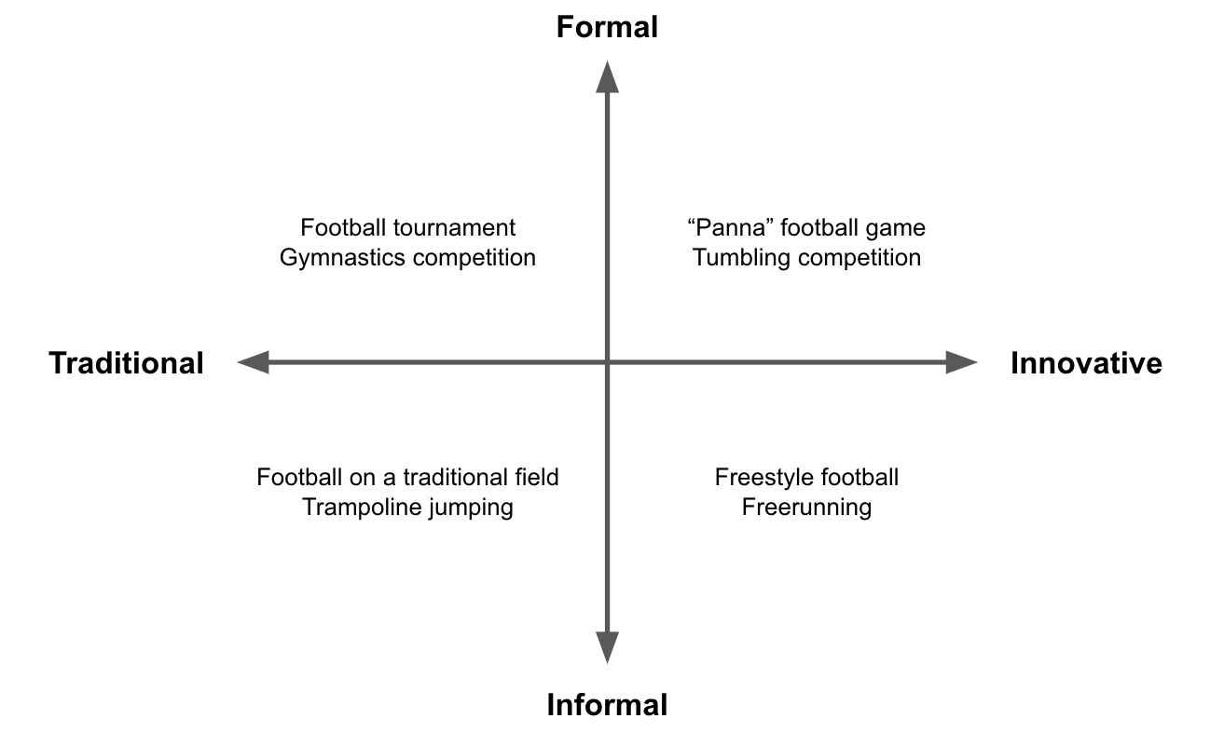

Figure 3 Quadrants of sports from football and gymnastics
The Student Union defines a traditional formal movement culture as objective and measurable where rationality and efficiency are central. The traditional/formal movement culture often provides hierarchical sports organizations. The continuation of traditional and formal sports organizations at the UT has top priority for the sports sector.
For the Student Union, innovative/informal movement culture means subjective, aesthetic, and often individual, sports experiences. Irrationality and emotion play a major role in the innovative/informal movement culture. The innovative/informal movement culture often takes shape through personal networks and self-organization. Only after maintaining the value of the formal and traditional sports organizations at the UT does the sport sector want to give explicit attention to new and informal sports and forms of movement.

