Guide on How to make an Annual Plan
In this guide we will explain what an annual plan is and how you can make it. We also add a template which you can use as inspiration for the structure of your own annual plan. As an example, the Student Union annual plan is also on the website (https://su.utwente.nl/en/board-corner/Associations-and-foundations/startingassociation/). It is important to remember that every association’s annual plan is different so do not be afraid to deviate from the template.

What is an annual plan?
The annual plan describes what you want to achieve in the coming year. It should reflect the long-term strategy but in a more concrete way.

How to start?
Start by brainstorming about what you would want to achieve with your association this year. Try to answer the following questions:
- What are current problems and what can you do to solve them?
- Where do you see more room for improvement within the association and how can you achieve this?
- Are there any new events you would like to organise?
- Are there any long-term (usually +/- 5 year) plans/goals that require steps this year?
- Are there any law/regulation changes that require your attention this year?
Try to think further than just the answers to these questions. If you have an idea for the cause of your problem, think about what could cause that in the first place, and so on. Also try to think about what implications and consequences each problem has. This way you get a problem cluster that can help you find the root of your problem. It can also help to determine if the consequences are high on your priority list or not.
For example, a problem that came from your brainstorm is that many events have low attendance. Your problem cluster could look as follows:
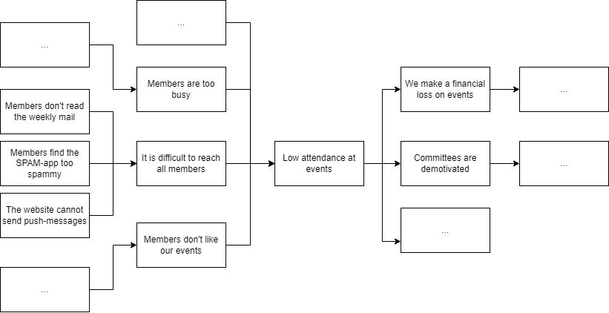
Possible solutions could thus:
- improving your weekly mail;
- making a communication policy;
- look into buying an app.;
- starting to look at student well-being due to members being too busy to partake in fun events.
- looking into the way you organize events;
- scrapping some of the yearly events.
Be aware that you probably have to set priorities because you can’t always focus on each cause.
We can see on the right side that we make financial loss on events and that we have demotivated committees. If you find committees very important this could propel it to become a very important point in your annual plan with a higher priority.
To gather more inspiration and input of your members, you could also organize input sessions, send a survey with questions, etc.

Structure
Once you have a plan formulate very clearly for each point what the problem context, the goal, and the actions are. Dependent on how strict you want to measure your achievements you can also add some indicators for when you have achieved your goal.
Provide a logical structure for you annual plan. Points that have high priority and/or are time and/or financially intensive are ranked at the top.
A chapter in your annual plan could look like this:
Chapter 1: Communication
The board has noticed that attendance at events has dropped in the last year and partly attributes this to bad communication. It is difficult to reach all members because there is not a clear communication policy and the weekly mail is badly read. The board also sees chances for improvements of the website.
Goal: Improve communication toward members.
Actions:
- The board will write a communication policy. This policy will focus on what information will be communicated through which platform. It will also include a policy on the SPAM-app detailing things such as how many messages may be sent a day and on which topics.
Subgoal 1l: Improve the weekly mail.
Actions:
- The board will look into a way to make the weekly mail more entertaining.
- The board will solve the problem of the weekly mail reaching the SPAM-folder of members.
Subgoal 2: Improve the website.
Actions:
- The board will look into the finances of buying an app and will give an advice by the end of the year if an app will be worth the costs.
- The board will improve the organisation of the entire website.
[Optional, you could also leave this out but write it down for yourself] Indicators:
We have achieved this policy point if:
- all action points are finished;
- attendance rate of every activity is at least 30% of the members;
- the members give the weekly mail a grade of at least a 7.5 average;
- etc.

