Appendix A, ordering list of Grolsch

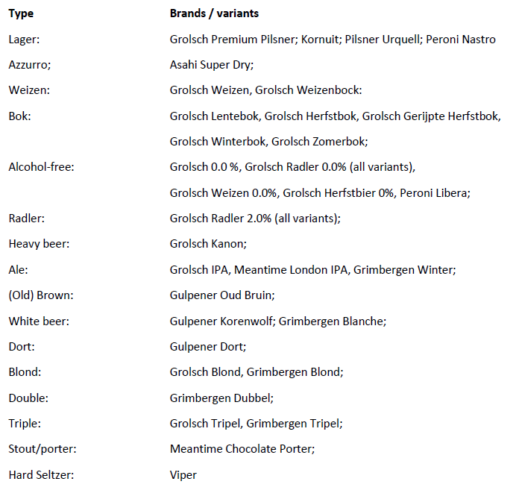

Appendix B, ordering list of Vrumona

Type | Brands / variants
Coke | Pepsi, Pepsi Max
Sinas | SiSi Sinas, SiSi No Bubbles.
Lemon Lime | Seven Up, Seven Up Free,
Bitters | Royal Club Bitter Lemon, Tonic, Ginger Ale and Ginger Beer. Double Dutch Indian Tonic Water.
Waters | Sourcy Blauw, Sourcy Rood
Flavoured waters | Sourcy Vitaminwater
Juices | Royal Club Jus d’Orange, Appelsap, Tomatensap
Cassis | Royal Club Cassis,
Sports drinks | Extran
Energy drinks | Rockstar
Kombucha | Butcha Kombucha Ginger & Lime Leaf, Blood Orange & Bergamot, Hop & Grapefruit, Raspberry & Magnolia
Other categories | Rivella Original, Rivella Cranberry, Rivella Green Tea en Ranja.
Ice Tea | Lipton Ice Tea Sparkling, Lipton Ice Tea Green, Lipton Ice Tea Green zero en/ of Peach

