Loof training & advies
We live in times of unlimited opportunities, at the same time these developments bring along a certain pressure to change. To remain flexible towards your environment and at the same time keep both feet on the ground, as a professional it is of importance to discover new solutions and learn how to apply them.
We combine our love for learning with a healthy ambition to really achieve results. This allows us to facilitate autonomous growth in people and teams, by applying various learning methods and ideas (i.e. ‘Brein Centraal Leren’). Coaching, training, mentorship and guiding of processes are all amongst the possibilities.
Our wide spread experience with business, Works Councils, in educational and government institutes as well as various social enterprises give us a realistic view on the needs of the market and the innovations that come with it.

Our approach?
At Loof we apply the latest neuroscientific insights on how the brain learn and develops, in our training. This enables us to increase the efficiency of these training days in the long-term. ‘Learning by doing’ is an important aspect of this. During sessions we keep a keen eye on your views developability and a growth mindset. To believe you can achieve something is the first step to actually develop a certain skill. This makes learning enjoyable, easy and efficient!

Developed specifically for the UT: PICK & MIX trainings
Loof offers various training modules that you can mix and match according to your needs. As a new team it is advisable to start with the option ‘Knowing what you want’. The team modules will form a good base for future teamwork, the remaining modules are a great add-on which you can insert to meet your own needs. With ‘PICK & MIX’ you will choose two modules which will compose your training day.
- Knowing what you want – picking priorities, vision and mission
- Teamwork and feedback – collaborating through core qualities and an open mindset
- Effective team through smart communication – collaboration and communication
- Brainwork and negotiation – smart negotiating
- Intercultural communication – bringing different cultures together
- Keeping the Board healthy – agile consultation, decisions, methods

Read more about what we offer, below.
Would you like more information? We are happy to assist, through phone or email: 072 589 1 589 | bureau@looftrainingen.nl.
Knowing what you want
Being goal oriented is one of the prerequisites of any succesful team. Being on your way to a fantastic term through a clear navigational point (goal), without bending any way the wind is blowing.

By discovering your Why, How and What you will be able to determine your navigational point (goal). How is the team going to achieve this and what does this mean for the tasks and duties there within? It is advisable to have these matters clear and concise from the get go. A clear navigational point, a concise way of working and knowing your tasks. How clear do you want it to be?

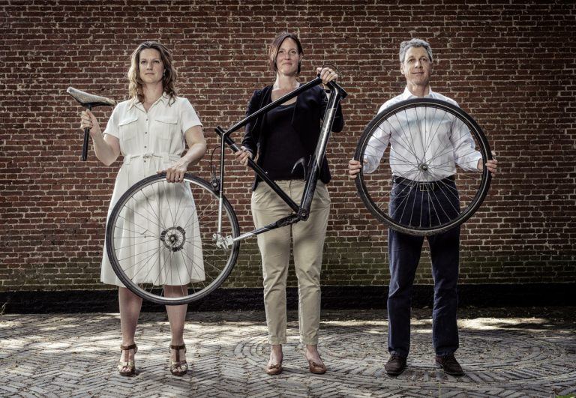
Teamwork and feedback
Working alone is faster, but together you are able to achieve more. Great teamwork is an essential part of being on your way to a great term. Gain insight in group dynamics, different roles and division of tasks, and in particular; learn to appreciate one another’s unique qualities.

An effective team stands out from other teams through an open mindset and open discussion on both positive and improvable matters. This is what drives innovation. Giving and receiving feedback is an important part of innovating. Getting to know yourself is the base of personal leadership and strength. Simply acknowledging someone’s positive sides and qualities can have an amazing effect. Developing this skill has the power to greatly improve collaboration, ambiance and performance within a team.

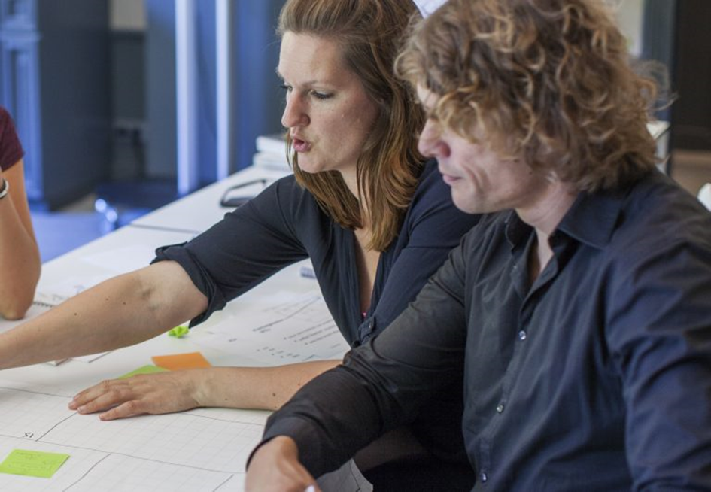
Effective team through smart communication
Collaboration comes to life through conversations, whether it is with your fellow students, colleagues or other members of the Board. Look forward to having a great time by learning about various communication techniques and possibilities.

In order to be able to collaborate, proper communication is essential. Easier said than done. Do you recognise the following? At times when you think you have communicated properly, it turns out the receiving end has interpreted your message in an entirely different manner. Other moments, everyone is talking at once or people do listen, but do not take action. Everyone can learn to communicate in a proper way! Having control over yourself, developing listening skills, exploring a meta position and guiding a process are important qualities of smart communication.

Brainwork and negotiation
Being on your way to a great term means sometimes you have to let things go. For example, old habits that are inefficient. Working smart and being able negotiate well is about doing what fits within the situation and what is needed.

Every individual has their own way of thinking, communicating and characterizing qualities. What are these differences and how do they reveal themselves? You will explore the personal preferences of team members based on a tried and tested model. Making these differences audible provides insight into the world of others. Knowing how who you are dealing with and what drives them creates a strong starting point for a conversation and/or negotiation. Personal preference/qualities and building a substantial case and point as well as how to apply this accordingly in practice, will be addressed.

Intercultural communication
All are welcome to your association, yet how do you make this diversity a shared responsibility? Through innovative ideas on how great collaboration is attained, you will learn how to enhance your magnetism towards students.

Is it just one biscuit with the coffee? Or is there food in abundance for anyone wanting to join the dinner table? Different cultures, sometimes have different habits and customs. These differences may also occur in communication. If this is the case, how do you really come in contact with one another? Do you go along with it? Or does the door get slammed in your face? How do you recognise these cultural differences, and do you bring it up for discussion? By truly connecting with someone you are able to empower the impact of your communication. Curious about new etiquette, curious about each other? Get acquainted with the possibilities that intercultural communication has to offer.

Keeping the Board healthy
What is health? When does stress arise? What does this mean long term and how do you notice it coming up? And how to act accordingly?

Vitality and health is important to people, teams, companies and institutes. The pressure of being on the clock plays a pivotal part in our modern society. Teams often experience time constraints. How does your team stay in good health? And what is needed to do so? Stress and pressure are perceived differently by every member within a team. Personal elements may or may not play a role in this. Therefore, setting your personal boundaries is of importance. How to do this? When do you notice your boundaries have been reached and what does this mean for the team? Whether it is working together, setting boundaries together or crossing these boundaries together … the key element in a healthy Board is doing it together.

